1. Which are the top three variables in your model which contribute most towards the probability of a lead getting converted?

**Answer: Tags, Last_Notable_Activity, Lead_Origin**

1. What are the top 3 categorical/dummy variables in the model which should be focused the most on in order to increase the probability of lead conversion?

**Answer: Tags_ClosebyHorizon, Last_Notable_Activity_SMSSent, Lead_Origin_Lead Add Form**

1. X Education has a period of 2 months every year during which they hire some interns. The sales team, in particular, has around 10 interns allotted to them. So during this phase, they wish to make the lead conversion more aggressive. So they want almost all of the potential leads (i.e. the customers who have been predicted as 1 by the model) to be converted and hence, want to make phone calls to as much of such people as possible. Suggest a good strategy they should employ at this stage.

**Answer**: If X Education want that almost all leads, so as per following screenshot the accuracy and Specificity of the prediction matters the most so the highest accuracy and high Specificity can be achieved using cutoff of **0.4**, which results in accuracy of around 88% with specificity (the proportion of true positives) as 92% and Specificity (the proportion of true negatives) of 84%.

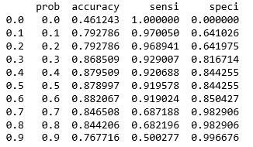

1. Similarly, at times, the company reaches its target for a quarter before the deadline. During this time, the company wants the sales team to focus on some new work as well. So during this time, the company’s aim is to not make phone calls unless it’s extremely necessary, i.e. they want to minimize the rate of useless phone calls. Suggest a strategy they should employ at this stage.

**Answer:** With the requirement of making minimum calls we would need to call leads to accurate lead conversion. With high accuracy, we can avoid making calls to people who have High probability to get converted. This can be achieved by 0.6 as the cutoff where the specificity is 85% and sensitivity is 92% along with accuracy of 88%.